The Hideyo Noguchi Africa Prize 2008
PRESS RELEASE
26 March 2008, Tokyo

The Government of Japan announces today its decision to award the inaugural Hideyo Noguchi Africa Prizes to Brian Greenwood and Miriam K. Were.

Medical Research
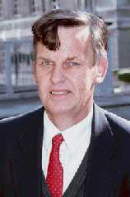
Brian Greenwood, born 1938 in the UK; British citizen; MD 1968 University of Cambridge, UK; Manson Professor of Clinical Tropical Medicine, London School of Hygiene and Tropical Medicine, UK

The Hideyo Noguchi Africa Prize for medical research is awarded to Brian Greenwood for his bold and innovative work on malaria. At a time when malaria was spreading uncontrollably across the African continent claiming more than 1 million lives a year, Greenwood contributed to creation and designing of effective strategies to control malaria. His crucial contributions in malaria research greatly helped developing the tools and knowledge that are essential in turning the tide on this terrible disease. His work brings hope where very recently only despair existed.

Pioneering field research on malaria
Greenwood has spent more than 30 years on site in Africa including 15 years as Director of the MRC Laboratories in the Gambia where he pioneered landmark research contributing to the understand of the immunology, pathogenesis and epidemiology of malaria, a major killer in Africa, and other infectious diseases such as meningitis and pneumonia, all major contributors to mortality among children in Africa. His research and translational clinical studies, involving simple but high quality methods as well as field trials of drugs and vaccines, have provided the scientific underpinning to a wide range of influential public health policies at national and international levels. His important contributions include:
- Demonstration of the effectiveness of insecticide-treated nets for control of malaria, which is now the cornerstone of malaria interventions throughout the continent, supported and financed by many donor agencies
Malaria endemicity
（source：World Malaria Report 2005）
- Primary studies on artemisinin-based combination therapies (ACTs), now widely adapted as first-line treatment for malaria
Pregnant woman and her infant sleeping under an insecticide-treated bed-net
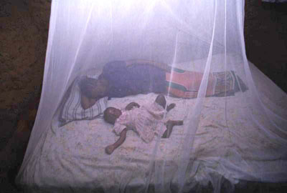
（source：WHO/TDR/Crump）

- Demonstration that malaria chemoprevention reduces child mortality. This is now being applied for intermittent preventive treatment in infants, children and in pregnancy
- Substantial contributions to trials of malaria vaccines, including the efficacious RTS, S vaccine
- Demonstration of how Haemophilus influenzae type b (Hib) infection can be eliminated by vaccination
- Large-scale clinical trials showing the potential for reducing child morbidity and mortality through use of pneumococcal conjugate vaccines
- Substantial contributions to the development of meningococcal vaccines.

Transformational approach to tropical medicine
Another important aspect of Greenwood’s achievements is his reinvention of field research in tropical medicine — changing it from an ancillary colonial or military activity focusing on hygiene to a multi-partite, multi-disciplinary endeavor, wherein holistic solutions are required — based on cutting-edge science and a genuine understanding of the complex eco-system as well as real-life challenges unique to Africa. Thus laboratory and clinical research, preventive and curative medicine, epidemiology, anthropology, and behavioral research were all brought together. These modern approaches which we now take for granted came from Greenwood’s prescience and leadership.
Anopheles gambiae (mosquito that transmits malaria)
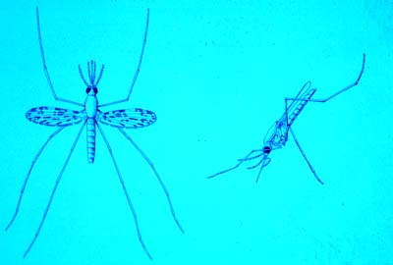
（source: WHO/TDR/Davies）

Research partnership with Africa
Over the years, Greenwood has made capacity building — another lasting legacy of his research based on African soil — a central objective including the training and support of young African scientists. A cohort of students, doctors, and clinicians who developed their careers under Greenwood’s inspirational mentorship has immensely contributed to the increase in stature of medical research in Africa amongst the scientific community in general.
Medical Services
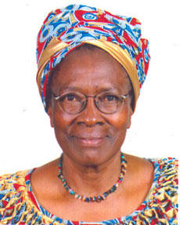
Miriam K. Were, born 1940 in Kenya; Kenyan citizen; Doctor of Public Health, Health Planning and Management 1981, Johns Hopkins University, USA; Co-founder and Health Specialist UZIMA Foundation, Kenya

The Hideyo Noguchi Africa Prize for medical services is awarded to Miriam K. Were, whose efforts to bring basic medical services and health rights to women and children in the villages of East Africa has been a beacon of hope for millions of people in Africa and the world. Through her work with African Medical and Research Foundation (AMREF) and UZIMA Foundation, Were has been a source of inspiration for all people on the African continent.

Community-based approach to health service
For the past 40 years, Were has dedicated her life to advancing the health and welfare of the people of Africa through a focus on the practicalities of delivering service at a local level. She has united communities to develop and implement innovative solutions to quotidian health problems. The most illustrious example of her community-based approach is her ongoing work to build public toilet facilities in local communities, improving hygiene and overcoming longstanding taboos. She also drastically raised the infant vaccination rate by organizing children into small groups to visit local clinics. Her innovation and systemic precedents have had enduring impacts not only in Kenya but throughout the East African region and across the entire continent, through her engagement with the African Union and as a key health advisor to the African Heads of State on AIDS, Tuberculosis and Malaria.

On-going battle against HIV/AIDS
Infection Rate of HIV/AIDS
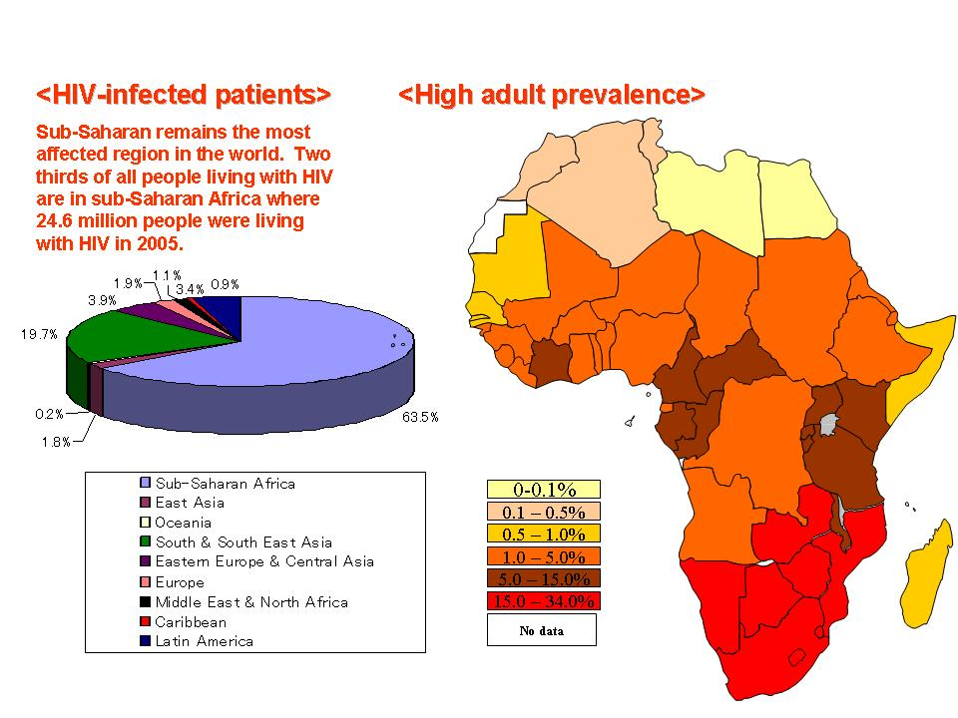
（source：UNAIDS Report on the global AIDS epidemic 2006）
Her style of work through the direct engagement of the youth, sex workers, intravenous drug users, homosexuals and others to encourage openness and frank discussion on sexuality and HIV/AIDS has galvanized communities in Kenya and contributed to the reduction of stigma and discrimination against people living with HIV/AIDS. She is a dedicated advocate for vulnerable populations, especially the poor and the marginalized. She is also committed to the empowerment and development of all voices across lines of sex, tribe, and age and class background. Widows and orphans severely affected by HIV/AIDS are amongst those most positively touched by her contribution to expanding access to medical services.
As the Chairperson of Kenya’s National AIDS Control Council, Were has provided strong leadership and orchestrated a balanced HIV/AIDS response agenda that has enabled Kenya to consistently register a reduction of HIV prevalence and AIDS-related mortality. Between 2002 and 2006, HIV prevalence in Kenya was reduced from 13 percent to 5.1 percent. By 2007, the country had 150,000 people on ARV drugs compared to 2,000 in 2002. Throughout, Were has stressed the role that people living with HIV and AIDS can play in the prevention, management and socio-mitigation of the AIDS pandemic.

Harnessing and focusing the energies of NGOs
As Board-Chairperson of Africa’s largest health non-governmental organization, the African Medical and Research Foundation (AMREF), Were has presided over the expansion of medical services to rural communities with an increase in Kenya’s national health budget by three times between 2003 and 2007.
Were is also the co-founder and director of the UZIMA foundation, where she has used her medical expertise and wisdom to encourage and promote positive behavior amongst youth. Drug addiction among UZIMA youth participants dropped from 80 percent to below 10 percent within six months and sexual and reproductive health has shown significant improvement.

UZIMA Foundation is a charitable trust registered in Kenya. ‘Uzima’ is the Kiswahili word for ‘abundant life’ or ‘good quality life’. UZIMA Foundation focuses on youth empowerment through improved health including control of HIV/AIDS and malaria.

